Slow-Roasted Citrus Salmon With Herb Salad

3/2020: great w lemons/oranges. used thyme, salmon had skin. Basting in middle helps.
3/2020: creamy, kids loved it. No lemons/organes. Salmon had skin.

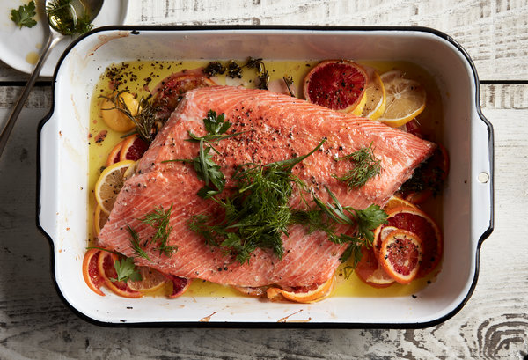

INGREDIENTS
- 1 (1 1/2-pound) piece skinless salmon fillet (or halibut or cod)
- Kosher salt and black pepper
- 2 lemons, Meyer or regular, thinly sliced, plus 1 tablespoon fresh lemon juice
- 1 blood orange, mandarin orange or regular orange, thinly sliced
- 6 sprigs thyme, rosemary, oregano or marjoram (optional)
- 1 ½ cups olive oil
- 2 cups herbs, such as parsley, cilantro, dill and tarragon, roughly picked from the stem
- Flaky sea salt, for serving
- Heat oven to 300 degrees. Season salmon with salt and pepper on both sides. Place in a large baking dish with sliced lemons, orange and thyme (or rosemary, oregano or marjoram), if using.
- Drizzle everything with olive oil and bake until salmon is just turning opaque at the edges and is nearly cooked through, 25 to 35 minutes.
- Toss fresh herbs with 1 tablespoon lemon juice and flaky salt. Serve alongside salmon.

